**DAILY ONLINE ACTIVITIES SUMMARY**

|  |  |  |  |  |  |  |  |  |  |
| --- | --- | --- | --- | --- | --- | --- | --- | --- | --- |
| **Date:** |  | **08-06-2020** | | |  |  | **Name:** | **Suhas Prasad Shetty** | |
|  |  |  |  |  |  |  |  |  |  |
| **Sem & Sec** |  | **8th B** | | |  |  | **USN:** | **4AL16CS080** | |
|  |  |  |  |  |  |  |  |  |  |
|  |  |  |  |  | **Online Test** | | **Summary** |  |  |
|  | |  |  |  |  |  |  |  |  |
| **Subject** | |  | **SMS** | |  |  |  |  |  |
|  | |  |  |  |  |  | |  |  |
| **Max. Marks** | |  | **60** |  |  | **Score** | | **54** |  |
|  |  |  |  |  | |  | |  |  |
|  |  |  |  | **Certification Course Summary** | | | | | |
|  | |  | |  | |  | |  |  |
| **Course** |  | **Exam Readiness:AWS certified Security-Specialty** | | | | | |  |  |
|  |  | | |  |  |  | |  |  |
| **Certificate Provider** | | | | **AWS** |  | **Duration** | |  | **2hrs** |
|  |  |  |  |  |  |  | |  |  |
|  |  |  |  |  | **Coding Challenges** | | |  |  |
|  | | | | | |  | |  |  |
| **Problem Statement-** : **generate all unique partition of integer.** | | | | | | | |  |  |
|  | | | | |  |  |  |  |  |
| **Status: completed** | | | | |  |  |  |  |  |
|  | | | | |  |  | |  |  |
| **Uploaded the report in Github** | | | | |  | **yes** | |  |  |
|  | | | | |  |  | |  |  |
| **If yes Repository name** | | | | |  | **Suhas** | |  |  |
|  | | | | |  |  | |  |  |
| **Uploaded the report in slack** | | | | |  | **yes** | |  |  |
|  |  |  |  |  |  |  |  |  |  |

**Online Test Details:**

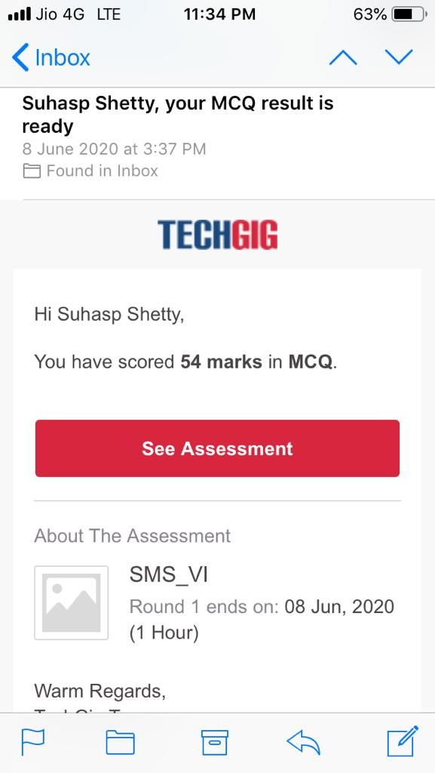

**Certification Course Details**



**Coding Challenges Details**

**def printArray(p, n):**

**for i in range(0, n):**

**print(p[i], end = " ")**

**print()**

**def printAllUniqueParts(n):**

**p = [0] * n # An array to store a partition**

**k = 0 # Index of last element in a partition p[k] = n # Initialize first partition**

* **as number itself while True:**

**printArray(p, k + 1) rem_val = 0**

**while k >= 0 and p[k] == 1: rem_val += p[k]**

**k -= 1 if k < 0: print() return p[k] -= 1**

**rem_val += 1**

**while rem_val > p[k]:**

**p[k + 1] = p[k]**

**rem_val = rem_val - p[k]**

**k += 1**

**p[k + 1] = rem_val**

**k += 1**

**print('All Unique Partitions of 2')**

**printAllUniqueParts(2)**

**print('All Unique Partitions of 3')**

**printAllUniqueParts(3)**

**print('All Unique Partitions of 4')**

**printAllUniqueParts(4)**